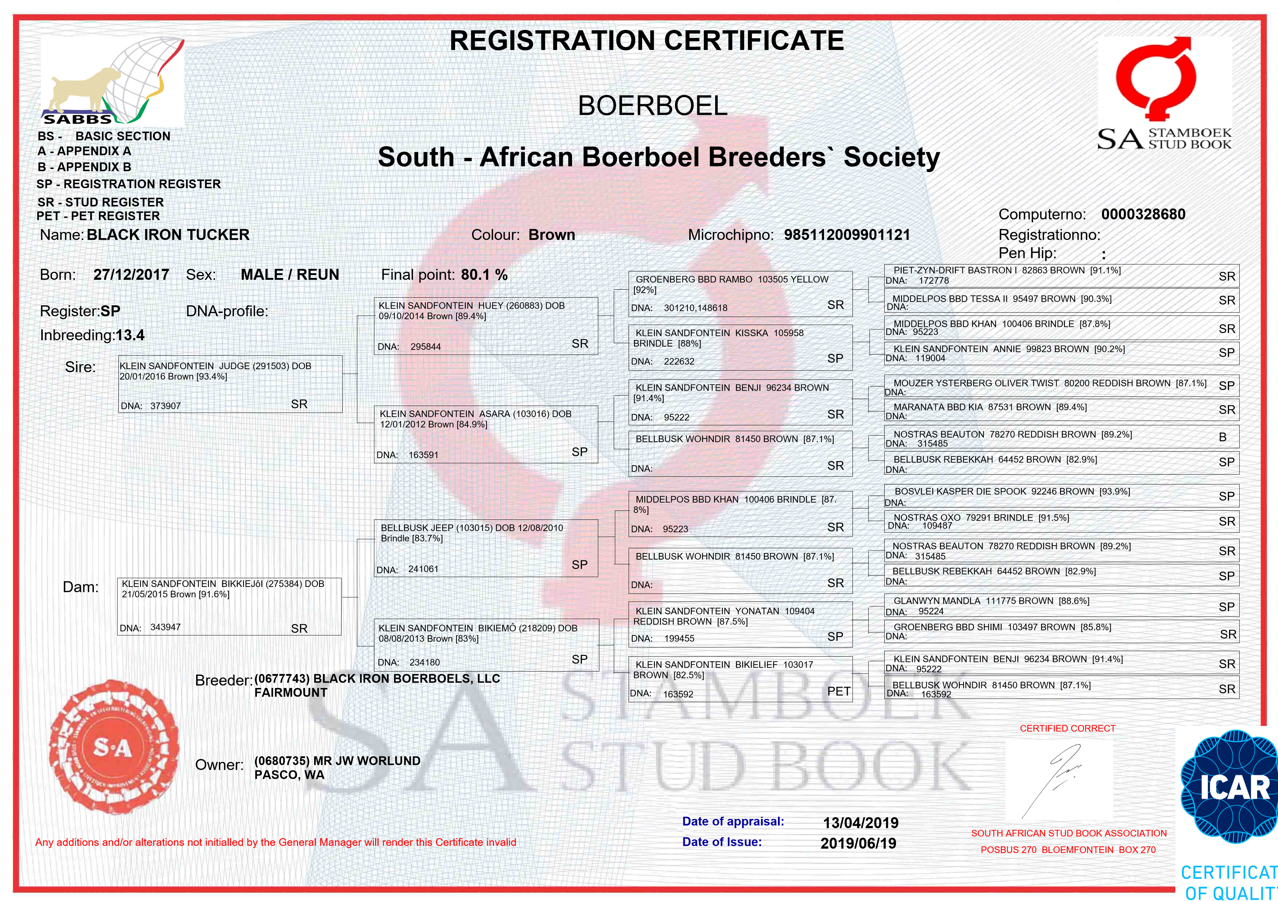
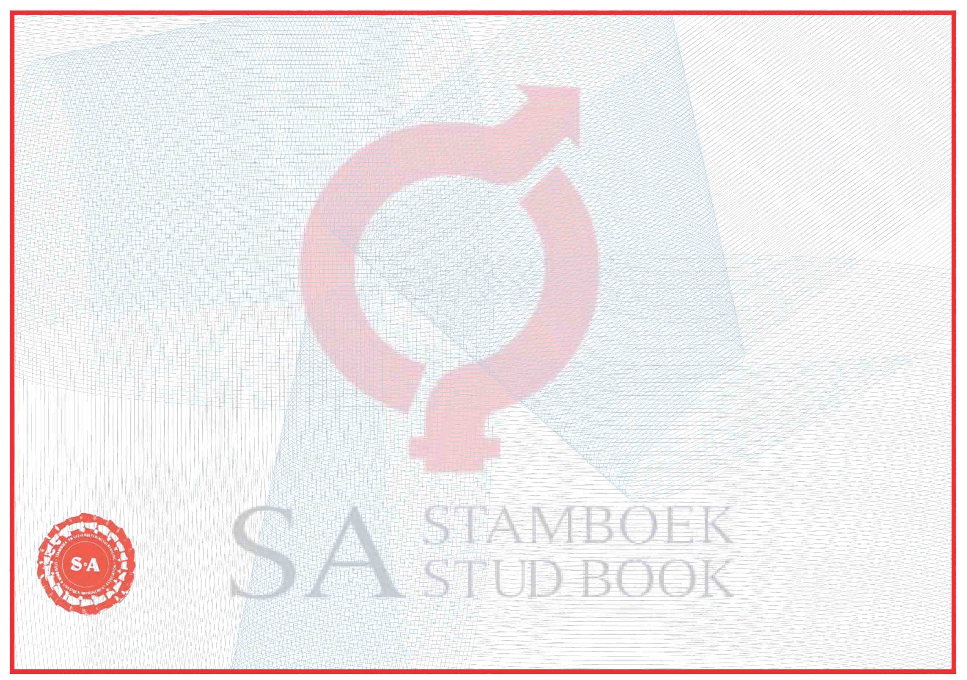

Date of
Name of Buyer
Address
Notification of death:
Seller
RECORD OF TRANSFERS
Kennisgewing van dood:
Signature of Owner:
Handtekening van Eienaar:
Notification of Castrasion:
Kennisgewing van Kastrering:
Handtekening van Eienaar:
Signature of Owner:
Signature of the G.M.
Delivery
Datum van
Aflewering
Naam van Koper
Adres
Verkoper
of the S.A.S.B.
Handtekening van die HB
van die S.A.S.B.
REKORD VAN OORDRAGTE
.
Date
Datum
Date
Datum
GENERAL MANAGER/HOOFBESTUURDER
Brown
12/03/2018
BLACK IRON BOERBOELS, LLC
PASCO, WA
MR JW WORLUND (Owner)
Unsure
Colour:
Kleur:
Eye Colour:
Oogkleur:
Masker:
Place:
Keurplek:
Mask:
BATTLEGROUND WA
MASKER (Min)
Med. status
HRT (0 ) PHC (: ) EBDISP (NO ) ENTR (FREE )
Med. status
CLASSIFICATION
Gen. Appearance
Head
Skull
Face
Nasal bone
Eyes
Earflaps
Neck
Centre Piece
Chest
Forelegs
Pasterns
Forepaws
Hindquarter
Hind paws
Skin/Coat
Health
Temperament
Movement
Forequarter
[7]
[3]
[6]
[3]
[3]
[3]
[5]
[6]
[4]
[3]
[2]
[4]
[15]
[15]
[5]
[4]
[8]
[8]
[3]
[8]
0680735

